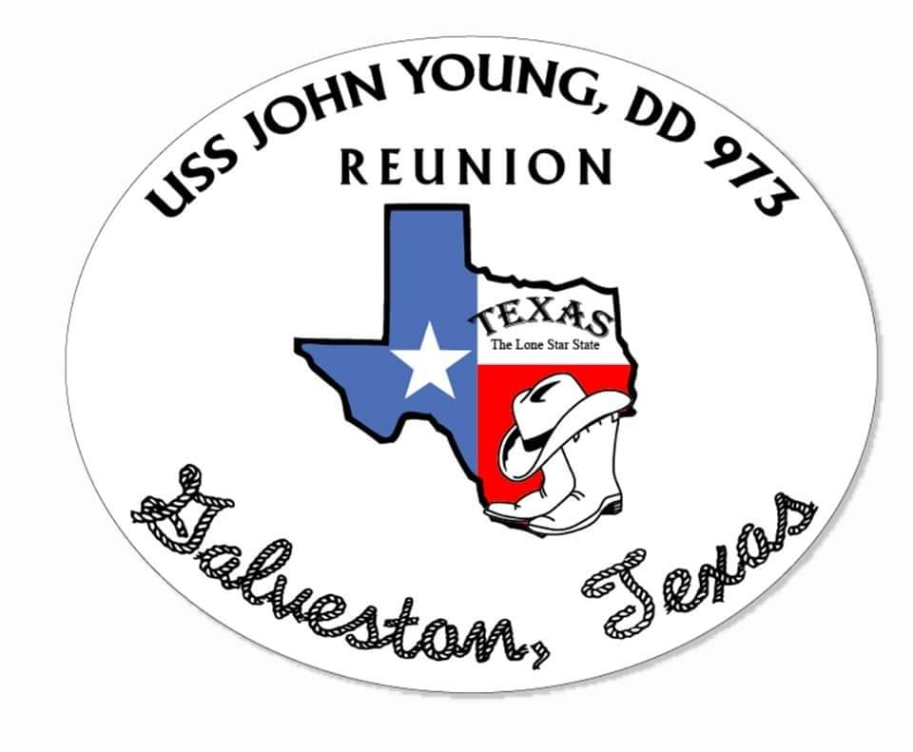

USS JOHN YOUNG, DD-973 REUNION
REGISTRATION FORM

The cost for the reunion is $50 per person. This covers the cost of the reunion related expenses. Events and activities are scheduled from June 10 – 13, 2021.

Please use this form to RSVP for the event.
I plan to attend. Enclosed is $ ___________ for _____ people.
I do not plan to attend this event. Please add me to your mailing list for
future event(s).

Please make check payable to :

USS JOHN YOUNG VETERANS ASSOCIATION
4108 Dalwood Drive
Holiday, FL 34691

